Record No: 0633
WILLIAM CLINCH
Of The Elms, Witney, Oxfordshire

Father of Margaret Hall Clinch (0632).
Rachel Bradshaw Clinch (married Thomas Forshew)
John Clinch (married Helen Townsend)

Birth: 13th April 1820
Baptised: 10th May 1820
Marriage: 19th August 1846 at Bampton Church, Rachel Hall Wright
Death: 5th August 1891 at The Elms.

Source: Somerville Index

Notes: Banker and Brewer
Director of Clinch’s Brewery.

At first he was educated by his mother, then went to school in Hanwell,and in 1837 was apprenticed to W.H.Holliston at Handsworth near Birmingham to learn brewing. Afterwards he was taken into the bank by his father, John Williams Clinch,(portrait with WBRBS) who had inherited the Witney bank from his father, John Clinch. Then, after the death of his brother John, and when his brother Charles had failed at the brewery, William at the bank took over the brewery too. His father ,John Williams Clinch, had been a very rich man and had set up his two sons John and Charles at the brewery, his two sons James and William at the bank and his son Edward in farming at Snow Hill.

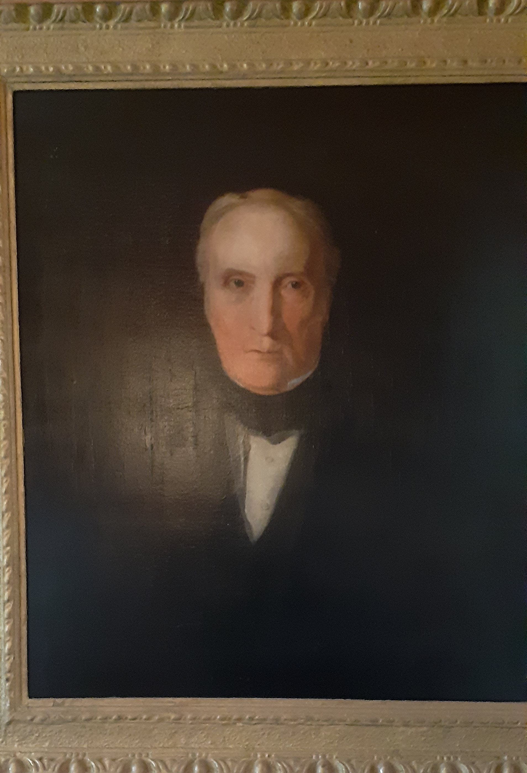

John Williams Clinch
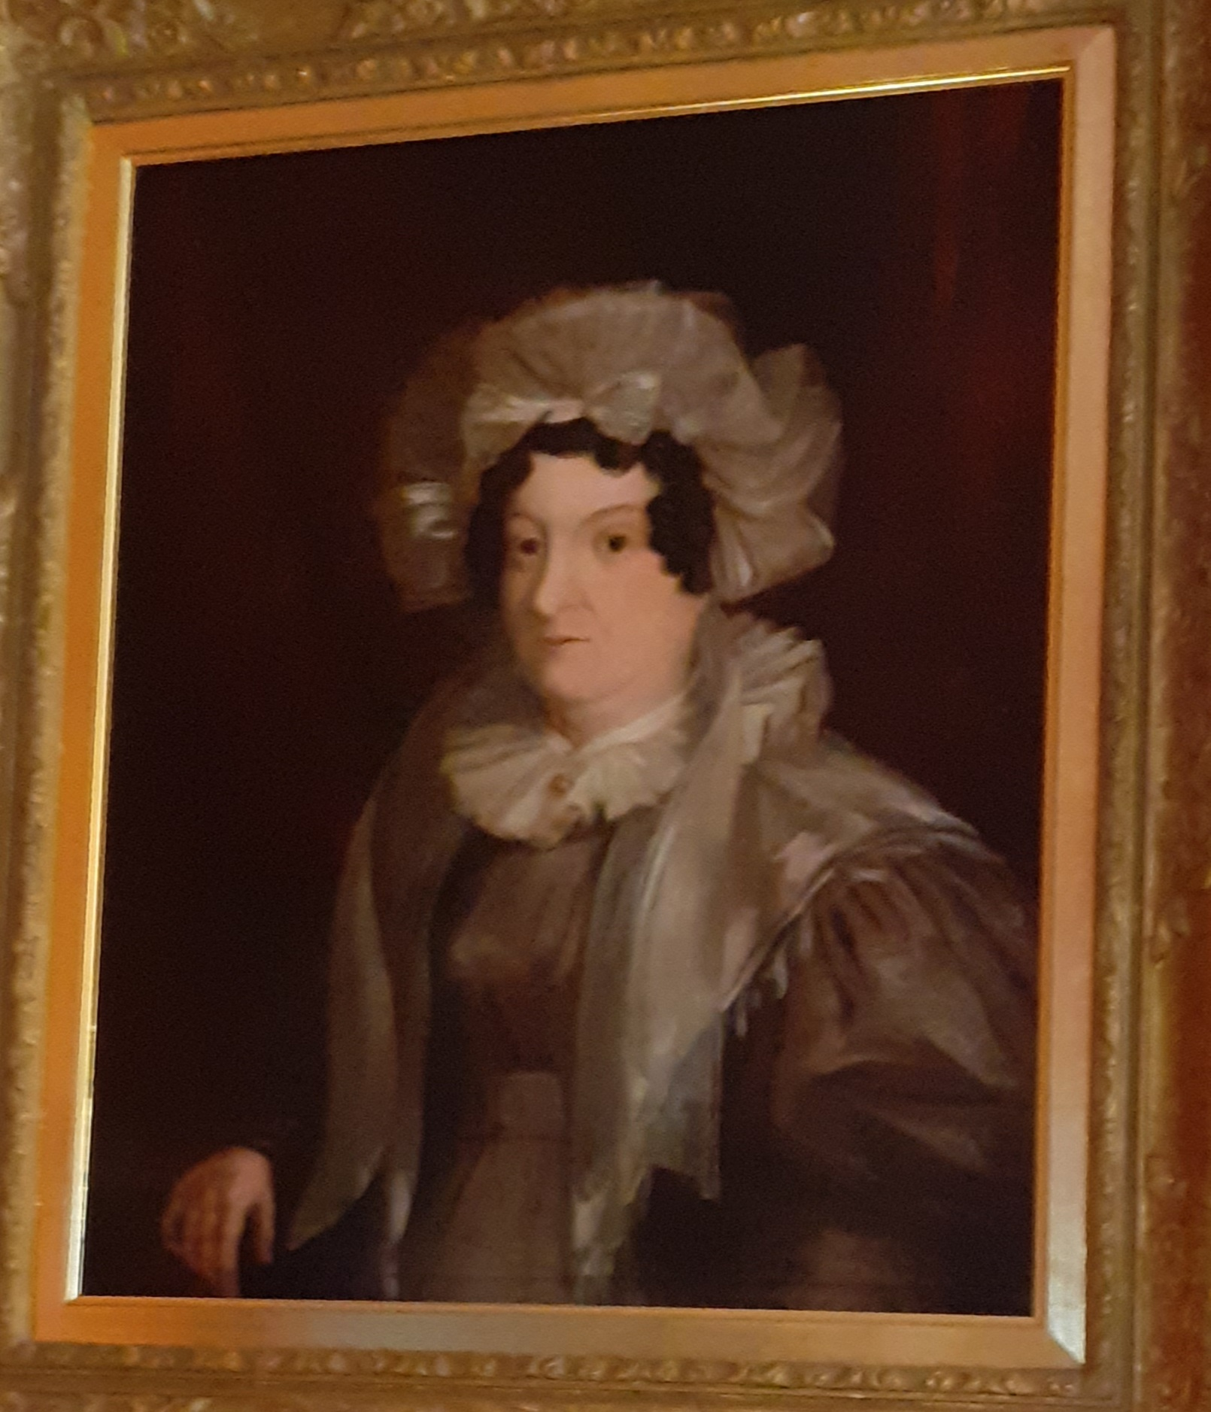

Betty Philippa Clinch, nee Cripps, wife of John Willliams Clinch
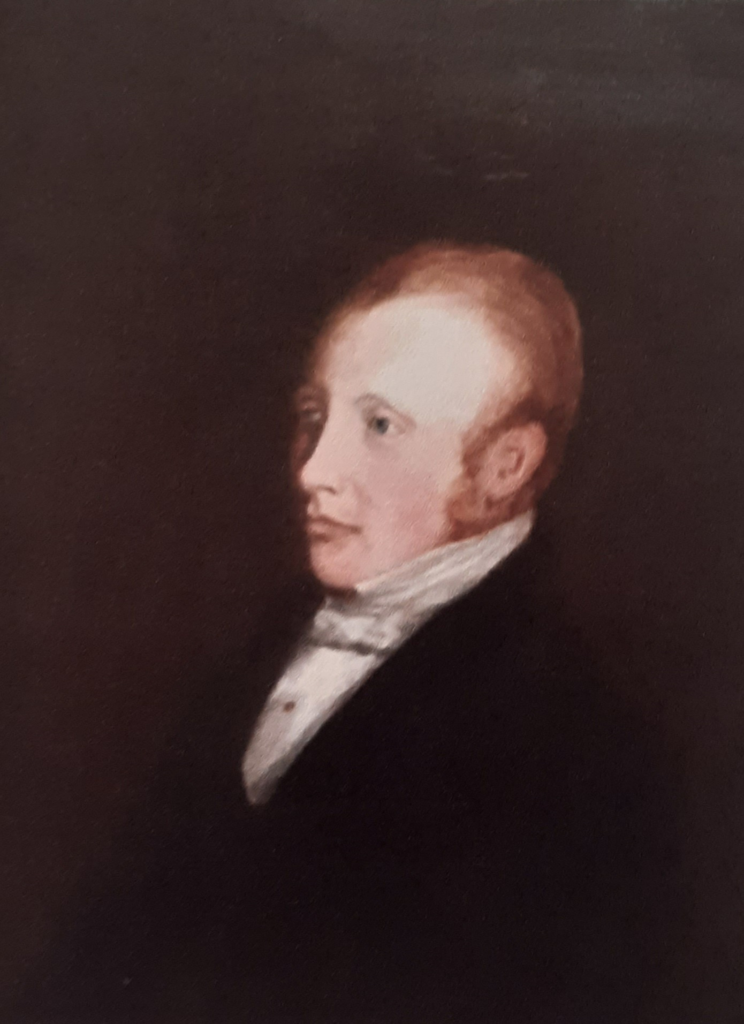

William Clinch, son of John Williams Clinch and father of Margaret Hall Clinch who married Bellingham Arthur Somerville.
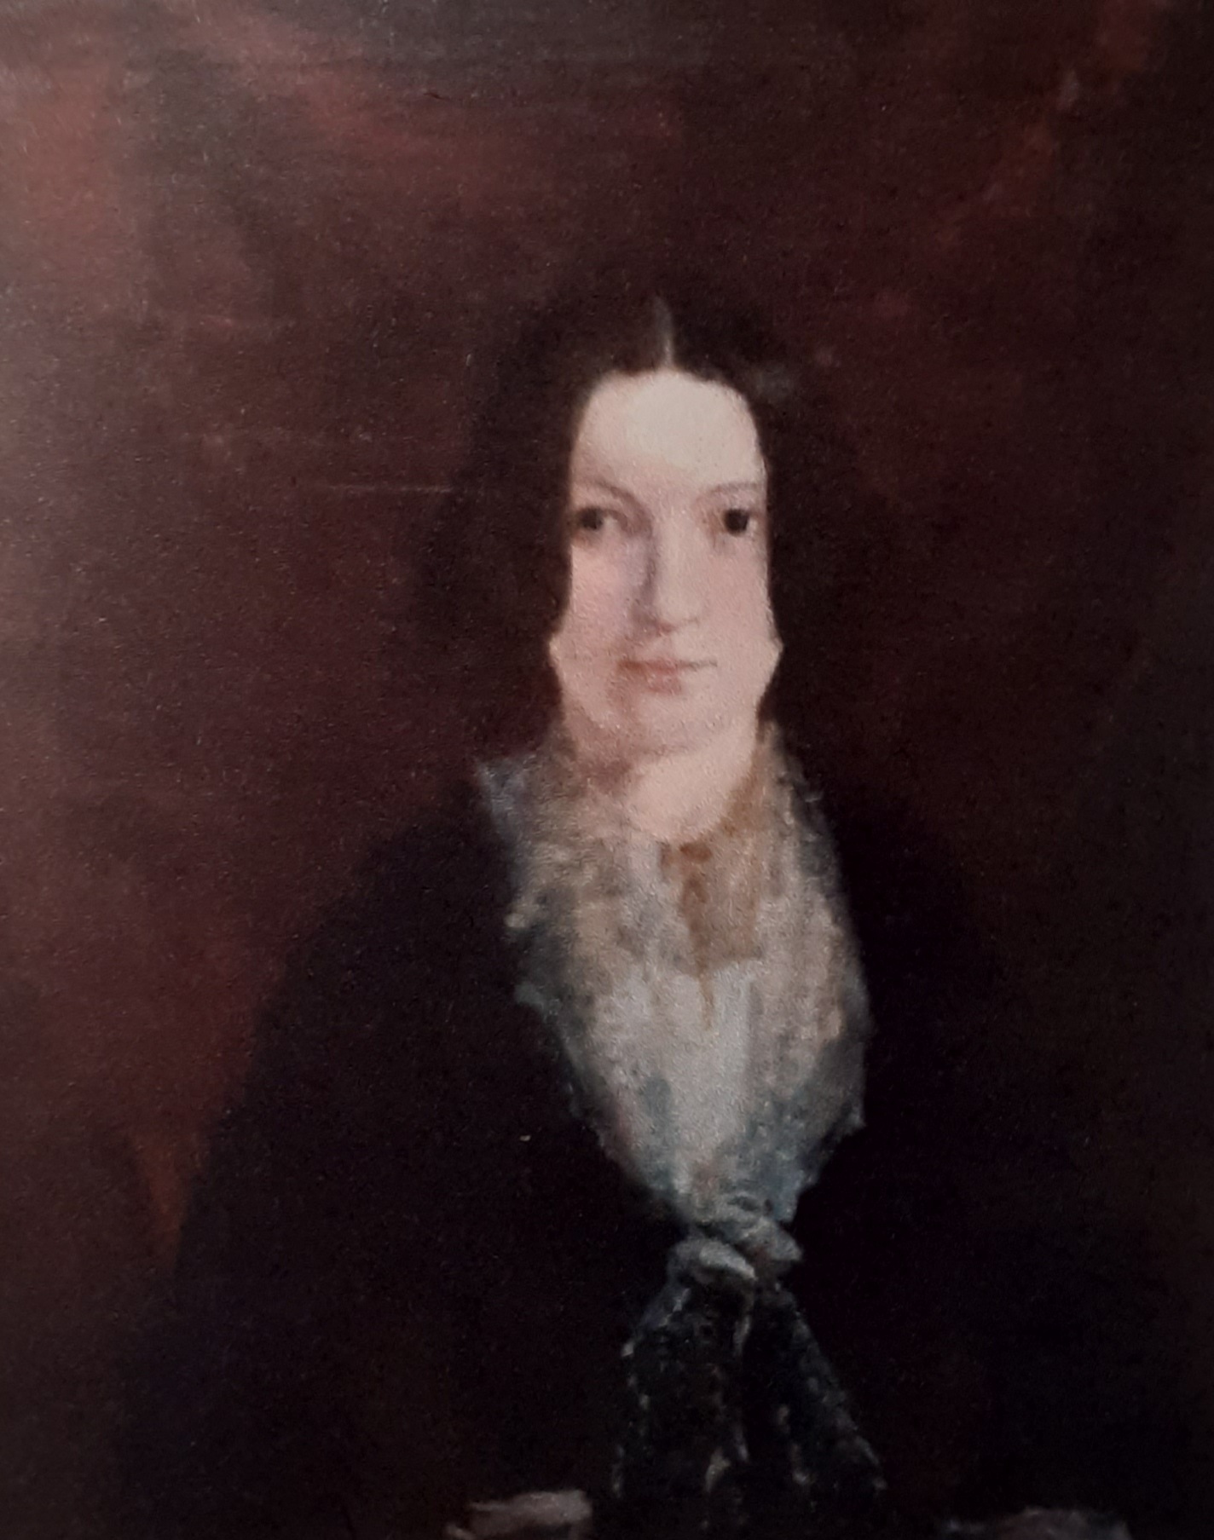
Rachel Hall Wright, who married William Clinch , mother of Margaret Hall Somerville.

